Power Distribution Gauge – BEV - CGEA 1.3

Functional Description

The Power Distribution Gauge information screen is used to educate the driver about the advantages of having an active Power Distribution system.

The power distribution shall show the amount of propulsion power and amount of regenerative braking power from the front motor vs the rear motor on an AWD equipped vehicle. The power distribution shall also show when the front/rear motor are disabled.

Interfaces

Interface Context Diagram (I/O Block Diagram)
Figure 1 Power Distribution Gauge Context Diagram

Inputs

IR-REQ-389116/A-INTERNAL

Operational_Mode
PT_Hyb_Cfg2
PWR_D_Gauge_Feature_Cfg

MUX messages on the CAN Bus

SIG-REQ-389111/A-WhlPwFront_Pc_Dsply Signal

Signal Name | Size (bits) | Detail | Units | Res. | Offset | State  Encoded | Min | Max
WhlPwFront_Pc_Dsply | 10 | Electrical power to front wheels | % | 0.2 | 0 |  | -102.2  (0x0) | 102.4 (0x3FF)

SIG-REQ-389112/A-WhlPwRear_Pc_Dsply Signal

Signal Name | Size (bits) | Detail | Units | Res. | Offset | State  Encoded | Min | Max
WhlPwRear_Pc_Dsply | 10 | Electrical power to rear wheels | % | 0.2 | 0 |  | -102.2  (0x0) | 102.4 (0x3FF)

IR-REQ-389118/A-Outputs
PWR_D_Front_Fill_Indicator
PWR_D_Rear_Fill_Indicator

Function/Performance

F-REQ-389119/A-Operational Modes

Mode | Differentiating Vehicle Conditions
Sleep Mode | PWR_D Gauge Function Off
Limited Mode | PWR_D Gauge Function Off
Normal Mode | PWR_D Gauge Function Functioning
Crank Mode | PWR_D Gauge Function Functioning

Voltage Levels

Refer to Cluster Features table located in Operational Modes and Voltage Range Strategies Section in this SPSS.

Human-Machine Interface

Visual

Indicator Graphics / Display Format(Graphics shown are typical examples, use correct images from Studio model)

Power Distribution

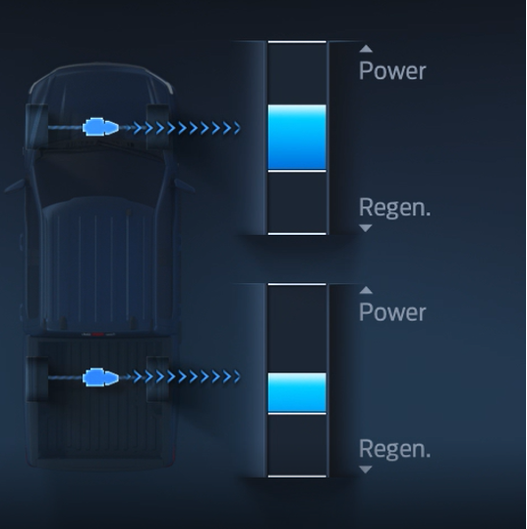
- 0-100% Gauge Fill
- Represents the magnitude of Propulsion power for rear motor
- 0-100% Gauge Fill
- Represents the magnitude of Propulsion power for front motor
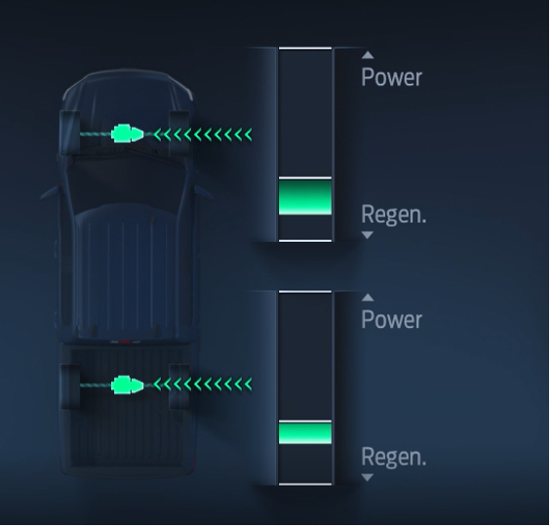
- 0 to -100% Gauge Fill
- Represents the magnitude of regenerative braking power for Rear motor

- 0 to -100% Gauge Fill
- Represents the magnitude of regenerative braking power for Front motor

Power level definition
Rear Motor Propulsion power level 0%

Rear Motor Propulsion power level 100%

Front Motor Propulsion Power level 0%

Front Motor Propulsion power level 100%

Rear Motor regenerative braking
Power level 0%

Rear Motor regenerative braking
Power level 100%

Front Motor regenerative braking
Power level 0%

Front Motor regenerative braking
Power level 100%

Indicator Color Coordinates

As per Ford Studio Drawing

Indicator Characteristics

As per Ford Studio Drawing

Audio

None

Switch Control Logic

Consumer access to the PWR_D Gauge Function’s display shall be as specified in the Menu Structure Section (STSS).

PFM-REQ-389120/A-System Accuracy

Within a 100msec of receiving a message that results in a change of state the cluster will update the display to the proper status.

Operation: Performance and Functional

Subsystem Algorithm Flowchart / State Diagram

F-REQ-389113/A-CAN Diagnostic Routine

F-REQ-389114/A-Front Motor Power Distribution Gauge Flowchart

F-REQ-389115/A-Rear Motor Power Distribution Gauge Flowchart

F-REQ-389121/A-Operation Description (supports algorithm flowchart /state diagram)
- The displayed PWR_D Gauge update rate shall be every 100ms or faster with Ford Core Driver Information approval.
- The gauge shall not be displayed when PWR_D_Gauge_Feature_Cfg = Disabled
- Front Motor Icon will change color in sync with Gauge Fill and will turn Gray when WhlPwFront_Pc_Dsply signal is > 102.
- Rear Motor Icon will change color in sync with Gauge Fill and will turn Gray when WhlPwRear_Pc_Dsply signal is > 102.

FS-REQ-389123/A-Function Safety Classification (EMC)

Class B

NVM-REQ-389122/A-Memory Storage

Parameter Name | Description | Value at Battery connect | Value at  Module Wake-up
WhlPwFront_Pc_Dsply | Power delivered by Front Motor | 0 | 0
WhlPwRear_Pc_Dsply | Power delivered by Rear Motor | 0 | 0
PWR_D_Front_Fill_Indicator | Front Motor Power Indicator | 0 | 0
PWR_D_Rear_Fill_Indicator | Rear Motor Power Indicator | 0 | 0
Operational_Mode | Input to this routine that is a 4 State indicator for cluster operational mode | As per Operational Modes and Voltage Range Strategies Section (STSS) | As per Operational Modes and Voltage Range Strategies Section (STSS)

Prove Out

No

Reconfigurable Telltale

No

Message Center Msg

Refer to Ford Studio Drawing

Error Handling

Missing Message Strategy

The signals will be declared missing as per the Diagnostics section of this SPSS.

DTCs states and history will be determined as per the Diagnostics section of this SPSS.

If PWR_D_Gauge_Feature_Cfg = Disabled (0x0), the cluster shall never log a missing message DTC due to this feature.

Invalid Data Strategy

See section 1.3.5.1

Diagnostics

Self Test

None

Engineering Test Mode

Reference section “Dealer / Engineering Test Mode (ETM)”

Part II Performance

Supported Diagnostic DIDs (Service $22 and $2E)

Supported Diagnostic Trouble Codes (DTCs)

DTC | Description

DCR-REQ-389117/A-DID DE00

Block  Num | Block Description | Byte(s) | Bits | State: Description | "0" | "1" | Default | Comments/  Information
PACKETED BLOCKS
$06 | Option Content (B&A) | * | 1 | PWR_D Gauge Feature | Disabled | Enabled | Disabled | Parameter allows Power Distribution display per … STSS on an ICE engine, and PD display per …STSS on a BEV.”
$09 | Option Content (B&A) |  | 3 | PT Hybrid2(PT_Hyb_Cfg2)  0x0 = Non-Hybrid  0x1 = BEV  0x2 = FHEV  0x3 = PHEV  0x4 = MHEV |  |  | 0x0 | Default from cluster plant to be 0x0 if cluster can be used on a Non-Hybrid.

Reference Specification

Revision History

SPSS Module Revision History

Revision Level | Name | Change Description | Date
1.0 | H. Sharma | Initial Version.  This request was brought to DICC on 05/07 by Charbel Bouery and due to high priority approved offline on 05/13 by Scott Watkins. DICC tracking #554 | 05/19/2020

